Project Report

* 1. INTRODUCTION
  2. Overview

A student internal mark management system deals with student academic related report colleges details and course details . It tracks all the details of a student from the day one to end of this course which can be use for all reporting purpose. The goals of this project is to create a system that will capture internal marks calculate final marks.

* 1. Purpose
* Internal assessment is a marks system.
* It gives the opportunity to subject faculty.
* It know students knowledge both in theory and practical
* Based on this information faculty will guide the students properly.

2. PROBLEM DEFINITION & DESIGN THINKING

2.1 Emphathy Map

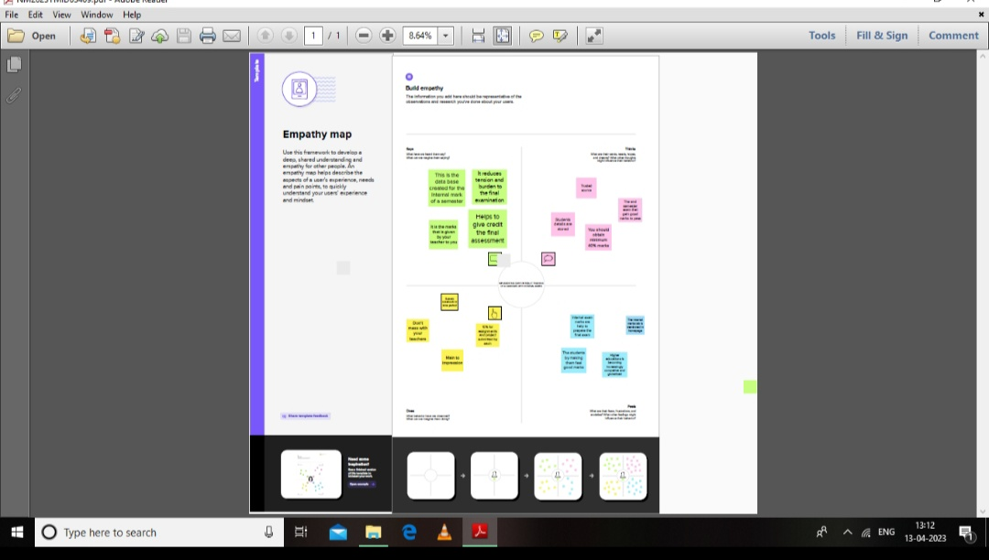

2.2 Ideation & Brainstorming Map

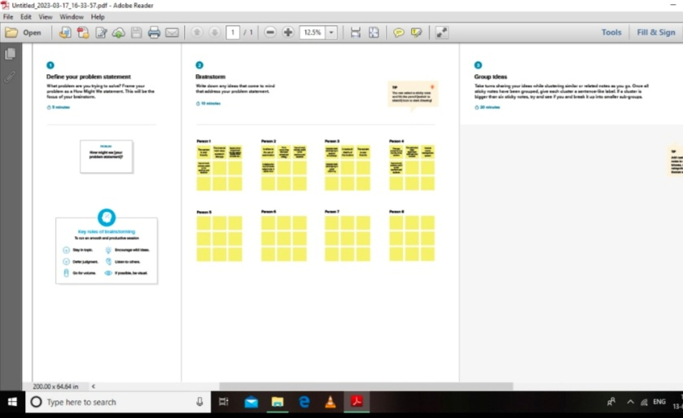

3. Result

3.1 Date Model:

|  |  |
| --- | --- |
| Object Name | Field in the Object |
| Semester    Candidate | |  |  | | --- | --- | | Field Label | Data Type | | Semester | Text |      |  |  | | --- | --- | | Field Label | Data Type | | Candidate | Text | |

* First creation custom object of candidate internal result card, for this Candidate Internal Result card we need to create 5 objects.

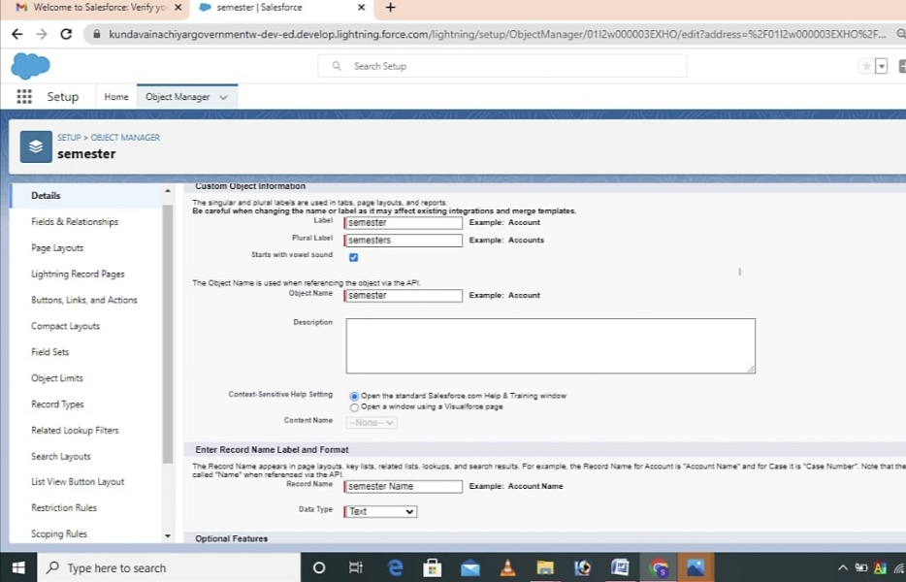

* A Group of tab that help the application function by working together as a unit. It has name, a logo, and a particular set of tabs.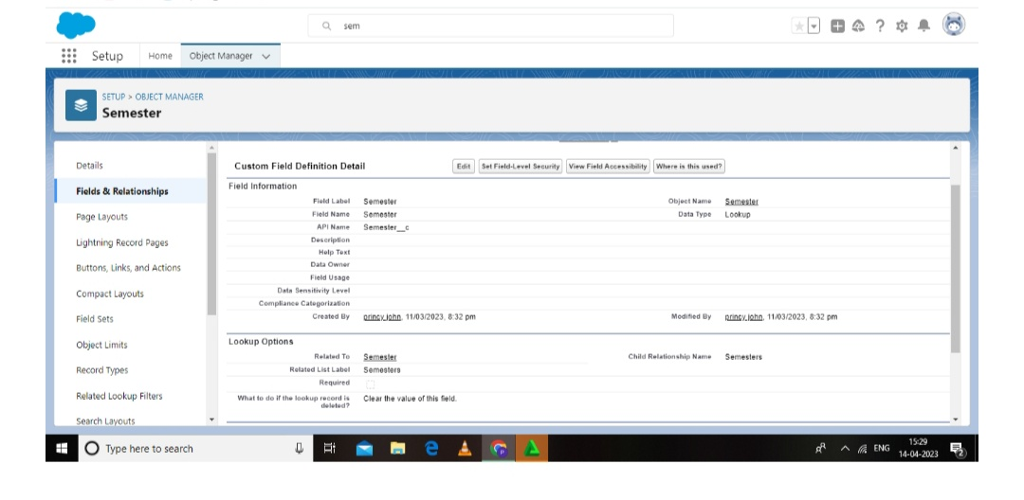
* **Finally, after completing those tasks, we get the reports of our project, dashboard.** 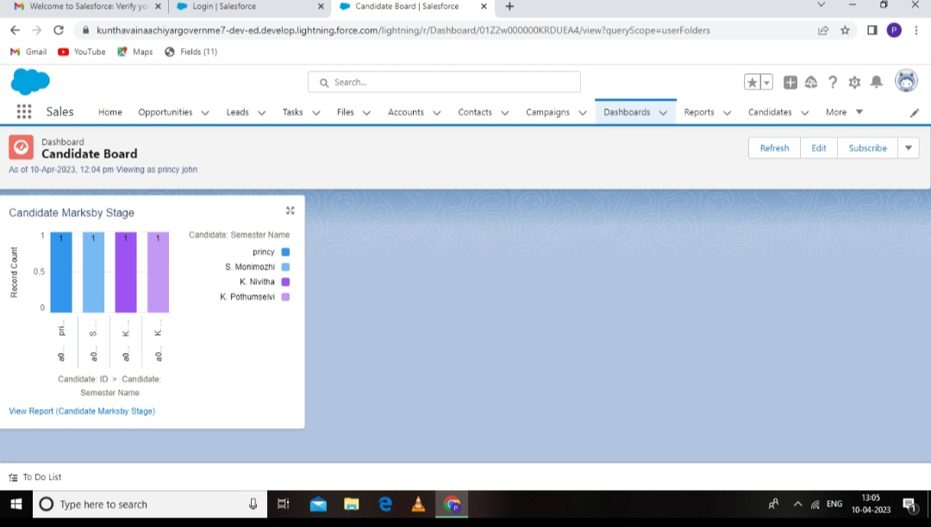

4. TRAILHEAD PROFILE PUBLIC URI

Team Lead –https://trailblazer.me/id/p2020batch7

Team Member 1-https://traiblazer.me/id/m2020batch4

Team Member 2-https://trailblazer.me/id/n2020batch

Team Member 3-https://trailblazer.me/id/p2020batch4

5. ADVANTAGES

* The help to give credit in the final assessment.
* It reduces the weight tage of external exams.
* Sometimes peoples are more willing to speak to insiders than to outsiders.
* An internal examination is very clearly a management tool.
* The organisation culture and the aims and objectives.

DISADVANTAGE

* Sometime paratiality and bias-ness to any occur.
* Teacher may miss-use this for their own benefits.
* Sometimes techers may give hints to some of the students.
* Learners need to challanged by the examination.

6. APPLICATION

* The complex and expensive MRP solutions emerged.
* Staff to a execute MRP software on mainframe computers.
* People soft created human source management system.

7. CONCLUSION

A student performance in his university exam can be perdicted with the help of his internal mark. There is a direct relation between the internal and the external marks. To helpful for the student and staff easy tracking system. The conclusion should be clearly relatedto the research question and the purpose of the experiment. We wish you student and teacher useful and essay in future.

8. FUTURE SCOPE

* It refers to the set of examination.
* It is is concerning the exam school and college.
* The system is user friendly.
* The can handle all thedetails a student.